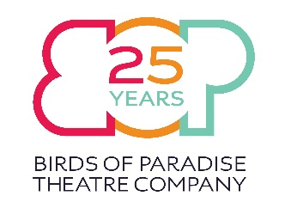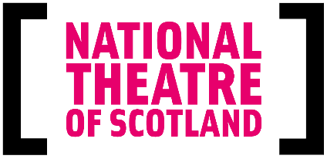

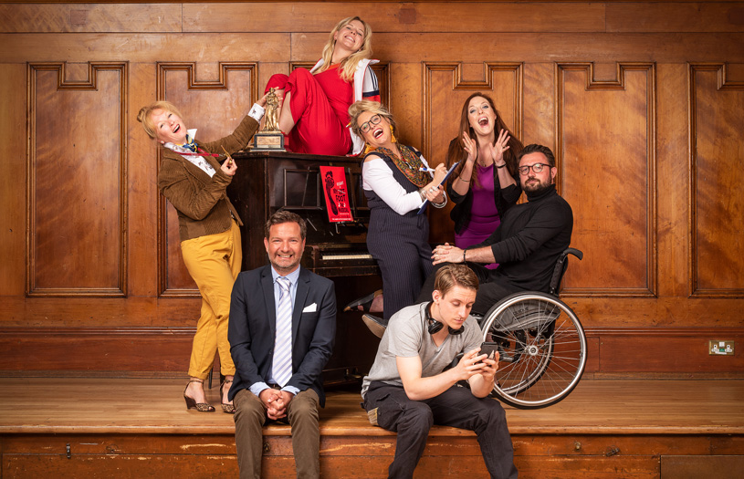
Relaxed Performance of My Left Right Foot
Assembly Roxy, Sun 19 Aug
Thank you for purchasing tickets to see the wonderful, the witty and the critically acclaimed My Left Right Foot! We wanted to get in touch about your chosen performance on Sunday 19th August. This will be a Relaxed Performance of the show, which means certain aspects of the production will be subtly altered and facilities will be available to create an Autism Friendly environment. Here’s an idea of what to expect.
- Seating in the front 10 rows will be more sparsely filled, to allow room to move around and for customers to feel uncrowded.
- Sound and lighting will be subtly toned down without compromising the artistic integrity of the show.
- Ear defenders will be available.
- Printed synopsis of the show will be provided.
- Audience members are free to get up and leave their seats and / or the auditorium and there is a relaxed attitude to audience noise.
- FOH staff are on hand to assist with any queries.
We hope that answers any queries you might have, but should you have any specific access requirements or anything you would like to discuss further or make us aware of, please feel free to get in touch with Birds of Paradise by Email at all@boptheatre.co.uk, Tweet us @BOPTheatre or on Facebook @birdsofparadisetheatre.

