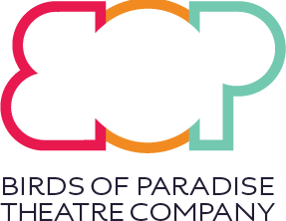
BOP Young Artists (2021):

Video Application Guidance

This application guidance is for BOP Young Artists 2021 – full details on our website, here.

Applicants must:
- Identify as being D/deaf, Disabled and/or Neurodivergent
- Live in Scotland (do not need to be a UK citizen)
- Come from a mixed heritage background

You can apply by video (following the guidance in this document); by online application form; or a downloadable application form. Details of these options can be found by clicking here.

If you need support with your application, you can email us at morna@boptheatre.co.uk or by 07758007646 (voicemail or text message)

Application videos should be no longer than 5 minutes (where possible). All applications should answer the following:

Please confirm to camera:
“I confirm that I: Identify as Disabled; have a mixed heritage background; am based in Scotland”
For more detail about what we mean here, please visit our website here

Then, please tell us:
- Your name

- Your date of birth

- Your postcode

- How you would prefer to be contacted by us (email, text, whatsapp, telephone call?)

- Your contact details (your email address or telephone number etc.)

- Would you need access to English language support during your time with BOP Young Artists? (If yes, please let us know what your primary language is)

- Let us know if you have any communication requirements that we should be aware of at the selection process stage (for example - I will require a Sign Language Interpreter for video calls or face-to-face communication - we will ask for more detailed access requirements once the selection process has been finalised.)

- Tell us what you love about performance, theatre or the arts in general

- What sort of things would you like to work on at BOP Young Artists?

- What difference would being part of BOP Young Artists make to you?

End of application form

Once completed, please send to morna@boptheatre.co.uk with the title ‘BOP Young Artists 2021 Application’. (An easy way to send your video is to go to WeTransfer.co.uk and follow their simple process)
If you want to, you can also send us some examples of your previous work when you send your application video to us.
The deadline for this opportunity is midnight on Sunday, September 5th 2021.

